**Nested If Else with Example**

A nested if is an if statement that is the target of another if statement. Nested if statements mean an if statement inside another if statement. C++ allow us to nested if statements within if statements, i.e, we can place an if statement inside another if statement.

**Syntax:**

if (condition1)

{

// Executes when condition1 is true

if (condition2)

{

// Executes when condition2 is true

}

}

**Flowchart**

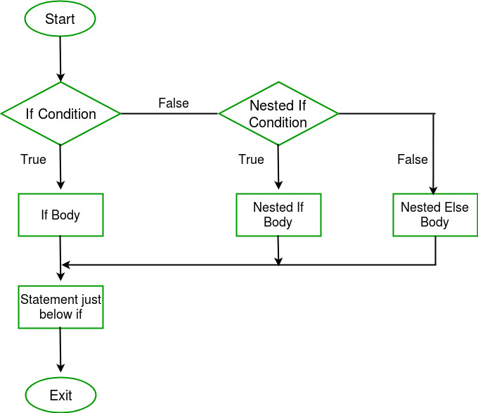

C++

// C++ program to illustrate nested-if statement

#include <iostream>

using namespace std;

int main()

{

int i = 10;

if (i == 10) {

// First if statement

if (i < 15)

cout << "i is smaller than 15\n";

// Nested - if statement

// Will only be executed if

// statement above is true

if (i < 12)

cout << "i is smaller than 12 too\n";

else

cout << "i is greater than 15";

}

return 0;

}

**Output**

i is smaller than 15

i is smaller than 12 too